THE CLIMATE OF A LARGE CITY AND ECOCLINE ORDINATION OF ITS VEGETATION COVER
Volodymyr P. Kycheryavyj ¹, Vasyl Popovych ^{2*}, Volodymyr S. Kycheryavyj ¹
¹ National Forestry University of Ukraine, Lviv, Ukraine
² Lviv State University of Life Safety, Lviv, Ukraine
Abstract: Large cities generate their own climate, which influences the distribution of vegetation cover and individual species population into separated ecological phytocoenotic zones – ecoclines. By the example of urban ecology research conducted in the city of Lviv with a population of about one million inhabitants, the nature of this ecocline ordination has been revealed. It is the result of action of vertical and horizontal gradients on woody plants phytovitality. The manifestation of these changes is increasing scarcity in phytocoenotic structure of vegetation, water deficit in the leaves, ratio distortion of the pigment composition. There are proposed certain methods for assessing the phytovitality of the introduced species. In the I EPhZ suburban forest we deal with the "new" climatope and edaphotope. In the II EPhZ - the park there is a forest-steppe climatope and edaphotope due to the thin vegetation and a larger area of open spaces. In the III EPhZ - in public gardens where open insolated spaces dominate – is steppe climatope and edaphotope. In IV EPhZ, where the high dryness of air and soil in streets and squares prevails, there is a desert climatope and edaphotope. In the I, II and III EPhZ soil temperature is always lower than the temperature in the crown, which corresponds to the physiological needs of plants. In IV EPhZ the soil temperature around the tree trunk is higher than the air temperature in the tree crown.
Key words: mesoclimate, edaphotope, climatope, impedance, gradient.
Introduction
Global warming, no matter its origin – naturally cyclic or human-induced (greenhouse effect ) is experienced, first of all, by large cities with their excessively large anthropized underlying surface which, in some cases, is several times larger than the surface covered by vegetation (Landsberg, 1981; Odum, 1986; Sukopp, 1990; Kucheryavyy, 1991). Accumulating large amounts of solar and anthropogenic energy, the anthropized underlying surface (pavement, buildings, roofing of various buildings and structures) gives it off into the city environment, changing climatic characteristics.
Climatic factors, in particular horizontal and vertical temperature gradients, form the basis of ecocline ordination of vegetation cover of large cities, which should be taken into account in the process of urban spatial planning (Sukopp, Wittig, 1993; Podhalanski, 2008).
Comprehensive studies of the conditions of urban ecosystems in regional cities of Western Ukraine carried out in the 1980s by scientists of the Pogrebnyak Forestry Institute and the M. Kholodny Institute of Botany, Academy of Sciences of Ukraine (Kyiv) revealed the fact that the location of vegetation cover in the urban areas may be of zonal and azonal character. Zonality is manifested in the peculiar features of phytocoenotic structure (species, space, age, population, environment) of green space in the following sequence: suburban forest – city park – city garden square – street alley. Natural thickets, mainly synanthropic vegetation, are considered azonal. As shown by a detailed study on the biological and ecological features of the vitality of plant groupings and individual woody plants, the main factor of this ordination is mesoclimate.
Numerous studies of urban dendroflora were carried out. Particular attention is paid to the meteorological conditions that influence the flowering of trees and the release of pollen. It should be noted that studies have included phenological observations, the amount of pollen and meteorological data on five sites in the center of Krakow during the period 2009-2011 (Stępalska, Myszkowska, Piotrowicz, Kasprzyk., 2016). A number of scientists prove that the period of tree species flowering in the city comes faster for 1.7 days every 10 years. This trend is a consequence of the rapid acceleration of air temperature increase since the 1990s (Czernecki, Jabłońska, 2016).
Conditions of the urban environment lead to accelerated passage of the main phenophases by plants, reduce their duration, reduce the period of vegetation and as a result - accelerated processes of plants aging and dying. One of the main factors that determine these processes is man-made. Negative influence on outdoor tree plants has an heavy traffic, the industrial enterprises, dense housing development, etc. Comprehensive assessment of the rhythms of plant development and growth is an important condition for the creation of scientifically based assortment of decorative plants that are resistant to adverse factors of the urban environment (Hanaba, 2017). The negative impact of the urban environment on the trees functioning is directly felt in summer months by street plantings and increases in the direction from the outskirts to the center of the settlement. In parks and public gardens both the conditions of the urban environment and the competitive phytocoenotic relationships make a negative effect on lime trees (Karpyn, Zayika, 2017).
The concept of ecological ordination of spatial distribution of communities was first introduced by Whittaker (1980) by putting forward three notions: grouping gradient (coenocline), complex environmental gradient, and ecocline (combination of coenocline and environmental gradient).
Based on this approach and considering the phytocoenotic structure of a suburban forest, city park, city garden square and street planting as part of the complex green area of the city (unified system of suburban and urban green spaces) four ecoclines can be distinguished, which we called Ecological Phytocoenotic Zones (EphZ) (Kucheryavyy, 1991). Whittekar’s approach to the study of biocoenoses made it possible to establish the direction of the gradients in the species populations and the nature of changes in the grouping parameters for the gradients of the urban environment. It should be noted that the attempts to distinguish populations of species by their potential capability to grow in various conditions of urban environment of the city of Poznan were made by A. Lukasiewicz back in the 1970s.
In the scientific literature, frequent assertions are made that climate indicators (temperature and humidity) change when moving from periphery towards the city center (Landsberg, 1983; Odum, 1986; Sukopp, Witting, 1998; Klausnitzer, 1990; Hanaba, 2017). Our research, conducted in Lviv, confirmed this tendency. At the same time, this research made possible, using the method of Radchenko’s vertical and horizontal temperature gradients (1966), to distinguish climatic ordination with more details and link it to characteristic representative groups of green space: forest, park, garden square, street alleys. Simultaneously with the study of the climatope state, it was also investigated the state of edaphotopes. Actually, it was the urbogenic environmental gradient that was studied here, the climatic factor being of primary importance.
The close relationship between climatic and edaphic gradients was noticed by the Ukrainian forester Belgard in the 1970s who was engaged with the problems of the steppe afforestation. The derivatives of complex interaction of these gradients is the level of soil moisture, the length of growing season, the accumulation of humus, the reaction of soil solutions and the accumulation of organic matter, the ratio of above-ground and underground plant mass, etc.
This difference, according to the author, changes towards semidesert. Previously, a similar idea was voiced by Radchenko (1966) who argued that the transition of «forest» gradient to «steppe» or «semidesert» leads to a change in the structure of phytocoenoses cover. Large cities, despite their smaller size compared to the areas of nature climatic zones, show a similar ordination (Fig. 1).
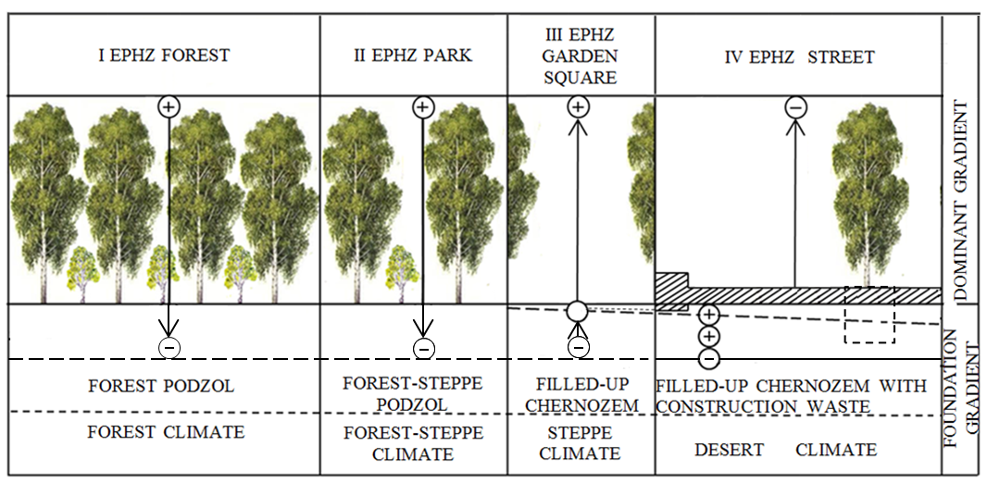

Figure 1. Ecological phytocoenotic zones of the complex green area of the city and temperature environmental gradients
In the suburban forest we deal with typical forest soils and climate and the negative temperature gradient of the environment. The summer temperature of the soil is lower than the air temperature in the crown, which positively affects the vitality of the plants. Somewhat different situation is in II EPhZ - urban parks, which is caused by their thin vegetation (conditions of forest-steppe climate). In public gardens where the edaphotope (bulk soils) and climatope (open space prevails) parameters are sharply changed, steppe climate is formed when the negative gradient passes into neutral (o) (III EPhZ). In open-air plantations with artificial soils and a large area of ​​the anthropized underlying surface (IV EPhZ), a positive temperature gradient prevails, which leads to weakening, premature aging and die-off of trees on the streets and squares (Fig. 1).

Data and Research Methodology
When studying the biogeocoenotic layer of the city of Lviv, we could not but pay attention to coenotic regularity of location of plant groupings and individual species of trees, shrubs and herbaceous plants according to the soil and climatic conditions which vary from peripheral suburban forest plantations to plantations in the streets and squares of the city. The reasons for this change, as we have found, is a change in mesoclimate on separate urban areas.
Lviv is a city located in the western part of Ukraine near the border with Poland and the population of about 1 million people. The climate of the city is mild, continental, the average temperature in January is -4 ° С, July - + 18 ° С. Precipitation is 550-700 mm. The vegetable surface of the city makes up about 45% of the whole territory and is represented by forest parks, parks, city and public gardens and a ramified system of street plantings (fig. 2). However, the growing area of ​​the anthropized underlying surface, which is the result of uncontrolled development of open spaces, complicates the urbanized conditions and worsens the state of plantations.
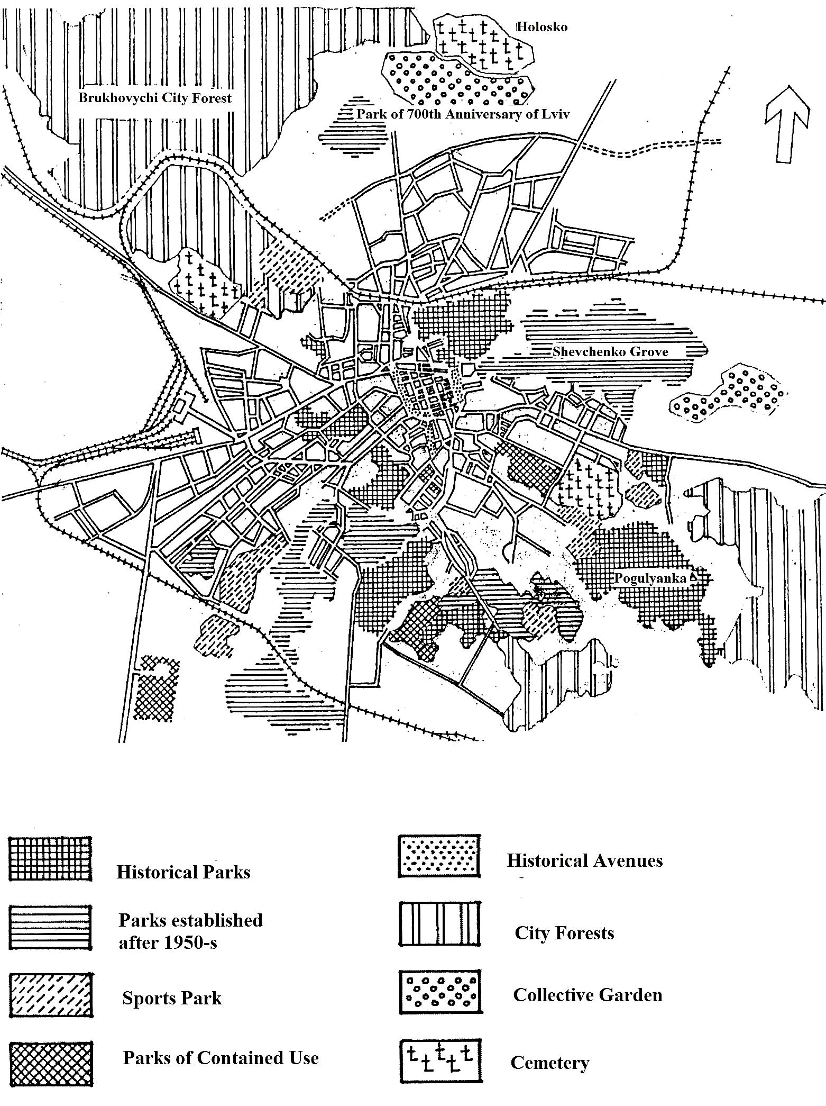
Figure 2 - Scheme of plantations in Lviv (Didik, Maximyuk, 2012)

The accumulation of large amounts of radiant and anthropogenic energy is for woody plants not only the source of heat, but also a major cause of overheating of both above-ground and underground parts of trees especially those that grow outside the phytocoenosis.
The idea, which has been prevalent since ancient times, that the climate is only associated with the ground layer of the atmosphere while the area of the rhizosphere is a branch of soil science, has not contributed to the emergence of biologists’ opinion about the possibility of various adaptations of above-ground and underground organs of plants to temperature variations.
The vertical temperature gradient (temperature difference between the roots and leaves that are at different points on the plant), which was proposed by Radchenko (1961) to assess the state of the environment, provides the opportunity to differentiate the state of the plant and environment which are closely linked. The vertical temperature gradient of the plant may be negative, zero, and positive. It is calculated by the following formula:
= (1)
where t_{a} - is the temperature of above-ground shoots (leaves) or the air in the crown of a tree; t_{s} - is the temperature of the roots or the soil in the zone of their location.
Radchenko found that for optimal functioning of the plant there should be negative temperature gradient (the difference between the air temperature in the crown and the soil temperature within the rhizosphere, according to the author, should be within the range of +3-8 °C. A positive temperature gradient of more than 4 °C, Radchenko says, contributes to the disruption of normal behavior of physiological processes and leads with time to fatal consequences. Temperature gradient is considered to be a zero one when the air temperature is equal to the soil temperature. This is an indication of the negative flow of physiological processes.
Radchenko also developed the theory of horizontal temperature gradients for the environment and plants by which he meant the difference of temperatures of the air and soil between selected points at the same horizontal level (‘thermal mosaic’).
To organize planning of Park-and-Garden management and to create new green space, one should take into account the horizontal temperature gradient that is calculated by the following formula:
(2)
(3)
where ТH_{a} – horizontal gradient of air; ТHs – horizontal gradient of soil; t₂ – t₁ - temperature difference between the measuring points t₂ and t₁.
To detect ecological ordination, a transect was laid, which covered the plantations of a suburban forest park, city park, public garden, and street alley.
In July when the level of radiation regime is the highest, the temperature of the air in the crown of the tree and the soil at a depth of 5 cm was measured. The temperature vertical gradient is calculated in the cameral conditions. To determine the effect of temperature gradients on the vitality of woody plants, which manifests in the duration of the growing season, the conditions of soil moisture, accumulation of humus, soil pH and the ratio of humic acids to fulvium were studied.
The effect of the vertical temperature gradient on the vitality of the plant was investigated by comparing the content of pigments in the Thuja occidentalis L. puddles, as well as the fluorescence index of chlorophyll. The level of vitality of Thuja occidentalis was investigated using electro-physiological methods - evaluation of impedance (resistance) and polarization capacity.
The spatial and species structure of phytocenoses was investigated by methods adopted in phytocenology.
The developed and proposed methodology for estimating the phytovitality of introducts is based on the ontogenesis of tree plants that grow in various EPhZs of Lviv.
Results and Discussion
The studies conducted (Kucheryavyy, 1991; Kucheryavyy & Popovych 2013¹) in four ecological phytocoenotic zones (EphZ) of Lviv (The Vynnyki forest (I), Pogulyanka park (II), the garden square on the Berms (III), Lychakivska street (IV) found a close relationship between temperature gradients, soil characterization of the site, and the length of the growing season.
The results of our investigations are presented in Table 1. As can be seen along with xerophilic air there occurs dehydration of the soil, which requires the selection of mesoxerophitic for EPhZ III and EPhZ IV such as Pinus silvestris L., Gleditsia triacanthos L., Robinia pseudoacacia L., Pinus pallasiana Lamb, etc.

Table 1. Edaphic climatic conditions of ecological phytocoenotic zones and the length of growing season
Indicators | Ecological phytocoenotic zones (EPhZ)
 | І | ІІ | ІІІ | ІV
Air temperature, °С (July) | 21.5 | 21.8 | 2.5 | 23.6
Soil temperature, °С (July) | 16.1 | 16.5 | 19.5 | 25.3
Vertical temperature gradient (±) | -5.4 | -5.3 | -3.0 | +1.7
Soil moisture, % (July) | 28.9 | 25.9 | 20.6 | 7.3
Soil humification, % | 1.9 | 1.08 | 3.8 | 4.5
Soil solution рН | 3.9 | 4.8 | 6.3 | 7.5
Humic acid- to- fulvic acid ratio | 0.5 | 0.7 | 2.6 | 9.9
Length of growing season | 182 | 179 | 168 | 144
A rise in temperature and the decrease in air humidity and soil moisture is accompanied by alkalinization of soils, which requires selection of calciphilous trees for these conditions. Therefore, it is not unexpected that acidophilic trees are very seldom to occur in EPhZ IV: Picea abies (L.) Harst, Larix decidua Mill., Betula pendula Roth., Carpinus betulus L. At the same time calciphilous trees do well under these conditions: Ulmus laevis Pall., Robinia pceudoaccacia L., Ailanthus altissima Swingle, Ligustrum vulgare L., Cotinus coggigria Scop.
Xerophilic urban soils lead to another negative phenomenon in the process of soil formation, namely, the predominance of humic acids, which slows down mineralization processes in the soil and results in disturbance of the biological cycle. This tendency is universally observed in street plantings: the ratio is greater than 1.0 or 2.6 in Lystopad Chyn street (green strip) and is up to 9.9 in Doroshenko street (circle around the tree trunk).
With reducing water supply to the trees in EPhZ III and EPhZ IV, the seasonal course of photosynthesis ceases to depend on the inflow of solar energy and is conditioned by the dynamics of moisture in the soil (Kucheryavyy & Popovych 2013²).
The decline in soil moisture from spring to mid-summer results in an increase in water deficit which is comparatively uncommon under natural conditions and it usually does no harm when being in the range of 10-13 %. As seen from Fig. 3, the average water deficit in the needles of Thuja occidentalis ‘Fastigiata’ amounts to 25.9 % (at positive vertical gradient of +1.5 °C). The highest level of water deficit is observed in June-July, the period of maximum production of biomass.

Figure 3. Field soil moisture (%) and water deficit (%) in the Thuja occidentalis ‘Fastigiata’ needles in the planting in Ivan Franko square

One of the problems that leads to increased xerophilic urban soils is their high degree of compaction (by passers-by, holidaymakers) since overcompacted soils (30 kg/cm² or more) exhibit a higher thermal conductivity, which also increases the positive vertical temperature gradient (Kucheryavyy, 2002).
Positive vertical temperature gradient of street planting influences pigment composition of the plants. This is evidenced by the data presented in Table 2, which compares the composition ratio of pigments for Thuja occidentalis ‘Fastigiata’ (50 years of age) in the Forestry University Botanic garden (EPhZ III) and two street plantings of the same age (EPhZ IV).

Table 2. The content of pigments in the needles of Thuja occidentalis in its ornamental forms in different site conditions⃰
Plant name | Location | Chlorophyll а, mg/g | Chlorophyll в, mg/g | Chlorophyll а/в | Carotenoids mg/g | Chlorophyll summation а+b | Chlorophylls Carotenoids
Th. о. 'Fastigiata' | Botanic garden, the city of Lviv | 0.59 | 0.31 | 1.90 | 0.22 | 0.90 | 4.01
 | Yefremov st. Lviv | 0.39 | 0.27 | 1.44 | 0.31 | 0.66 | 2.13
Th. о. 'Smaragd' | Botanic garden, the village of Stradch | 0.73 | 0.35 | 2.08 | 0.27 | 1.08 | 4.00
 | Yefremov st., Lviv | 0.38 | 0.14 | 2.70 | 0.13 | 0.52 | 4.00
Th. о. 'Ericoides' | Botanic garden, Stradch | 0.59 | 0.28 | 2.10 | 0.17 | 0.87 | 5.12
 | Gen.Chuprynka st., Lviv | 0.48 | 0.20 | 2.40 | 0.23 | 0.68 | 2.90
Kucheryavyy, 2011
The electro-physiological method of express-analysis (used by Zimmermann, Brawn, 1981) confirmed the influence of vertical gradient on the territorial nature of metabolism of individual trees of Thuja occidentalis ‘Fastigiata’ which grew under different urbogenic conditions. As it turned out, the value of electrical resistance (impedance) in weakened trees in the city square is much higher (70%) than in favorable conditions of the park. At the same time, the polarization capacity in the weaken trees that grew in Ivan Franko square was 73 % less than that in the park (Fig. 4).

Figure 4. Values for impedance and polarization capacity of individual trees of Thuja occidentalis “Fastigiata” under growing conditions of EPhZ II and EPhZ IV

A low level of vitality of individual trees of Thuja occidentalis ‘Fastigiata’ under unfavorable arid conditions of the streets was revealed as a result of experiments involving the kineticts of photoinduced fluorescence of the needles (Table 3). The validity index calculated by this method confirmed the negative impact of city streets climate on the vitality state of plants (Kucheryavyy, 2012).

Table 3. Indexes of chlorophyll fluorescence for Thuja occidentalis ‘Fastigiata’⃰
Location of study object | Assessment of the site according to 5-point system | Indexes of fluorescence |  | Vitality index  Rtd
 |  | Background  Fo | Maximum  Fm
Forestry University Botanic garden | 5 | 12 | 34 | 0.64
Svoboda avenue | 4 | 18 | 34 | 0.44
Gorbachevsky street | 3 | 20 | 30 | 0.33
Kucheryavyy, 2012
Considering the difference between horizontal and vertical temperature gradients of air and soil of the ecological phytocoenotic zones of Lviv, four climatic gradients are distinguished arbitrarily: forest (suburban forests), forest-steppe (city parks), steppe (garden square), and desert (street planting). The planting of these EPhZs is characterized by different phytocoenotic structure, species composition of the trees, shrubs and grasses, the ratio of native species and exotics, natural and synanthropic vegetation (Table 4).

Таble 4. Spatial and species structure of plant communities located in different ecological phytocoenotic zones of Lviv sity
EPhZ | Object name | Vertical stratification of phytocoenosis | Trees (quantity) |  |  | Shrubs (quantity) |  |  | Grasses (quantity)
 |  |  | native | exotics | total | native | exotics | total | forest-growing | synanthropic | total
I | Vynnyki forest | Three layers | 12 | 3 | 15 | 7 | - | 7 | 37 | 4 | 41
II | Pogulyanka park | Two layers | 9 | 6 | 15 | 4 | 15 | 19 | 25 | 10 | 35
III | Garden square on the Berms | One layer | 3 | 8 | 11 | 1 | 7 | 8 | 5 | 19 | 24
IV | Lychakivska street | - | 2 | 3 | 5 | - | 3 | 3 | - | 16 | 16

At the same time, street planting surrounded by anthropized underlying surface of roads and pavements which accumulate large amounts of solar energy, as well as compaction of the soils, promote the formation of ‘desert climate’. Therefore, in all cases we deal with with a shift of climatic indexes towards the South-like, drier climate that occurs in the latitudinal distribution of climates (Table 5).

Таble 5. Air temperature of July in the green areas in the city of Lviv, compared with the climate of other cities
Name of a city | Average July temperature °С | The name of the city object | Air temperature, July, noon °С | EPhZ
Lviv | 18.5 | Vynnyki forest | 20.7 | I
Kamianets-Podilskyi | 19.0 | Stryiskyi park | 21.2 | II
Odesa | 22.1 | Ivan Franko square | 22.4 | III
Cairo | 26.0 | Gorbachevsky street | 23.4 | IV

In order to prevent the vital functions of plants from weakening which occurs under the influences of xerophilic process, it is desirable to conduct monitoring of the vertical temperature gradient, this being simple and easy for utility workers to perform. You need to have two thermometers: one to measure the temperature of the soil, the other to measure the temperature of the air in the tree crown. In case the soil temperature exceeds the temperature of the air (or else the air temperature approaches this parameter), there is a need to regulate the thermal regime, for example, to cool the soil by watering or sprinkling the tree crown.
Artificial restrictions on the development of root system of trees growing in the streets, both in depth and width, constant overheating and dehydration of soil within the rhizosphere reduces the assimilative activity of the aerial part and accelerates the process of ontogenesis. All this leads to physiological aging and premature tree mortality. The reason for these negative processes is the early ‘ashing’ of physiologically active plant organs (roots and leaves) caused by impaired carbohydrate metabolism, increased respiration, inhibition of photosynthesis, generation of harmful products, protein degradation, etc. This raises the question of prospective introduction of woody plants under conditions of EPhZ III and EPhZ IV. And not only exotics, but native species as well. Fagus silvatca L. that is widely represented in suburban forests and city parks of Lviv such as Pogulyanka park and Zalizna voda park, does not occur in the garden squares and street planting. This also applies to the populations of Picea abies Karst and Abies alba Mill. growing in the suburban forests of Roztoche. However, we should think how to ensure the adaptation of these species under the conditions of EPhZ III and EPhZ IV.
As a result of long-lasting studies that were conducted within the complex green areas in the city of Lviv, it has been developed an evaluation methodology to assess the phytovitality of introduced species (Fig. 4).
Urbophytovitality of introduced species

 |  | EPhZ
attributes |  |  |  |  |  | evaluation
 |  | I | II | III | IV
natural life cycling |  | + | + | ± | - |  | high stability  medium stability  low stability | 1  2  3
development cycle of shoots |  | + | + | ± | - |  | full cycle  full cycle with small deviation  full cycle with significant deviation | 1  2  3
development cycle of flowers and fruits |  | + | + | ± | - |  | full cycle  full cycle with small deviation  incomplete or absent | 1  2  3
development cycle of leaves |  | + | + | ± | - |  | full cycle  full cycle with small deviation  full cycle with significant deviation | 1  2  3
reproduction capability |  | + | + | - | - |  | intensive propagation  artificial propagation  poor artificial propagation | 1  2  3
preservation of natural life-form |  | + | + | + | ± |  | preserves  preserves, slightly slowing down the growth  preserves significantly slowing down the growth | 1  2  3
natural rate of ontogenesis |  | + | + | ± | - |  | of natural character  of natural character slightly accelerated  of natural character significantly accelerated | 1  2  3
phytovitality |  | + | + | ± | - |  | high  medium  low | 1  2  3
 |  | low resistant |  | medium resistant | resistant

Figure 4. Urban vitality of introduced species

An assessment of the phytovitality of introduced species can be applied to large cities, where all 4 ecological and phytocoenotic zones are observed.
It is based on phenological observations of the natural rhythm of the plant life, the development cycle of leaves, shoots, flowers and fruits, the ability to reproduce, the preservation of natural life-forms, the nature of ontogenesis.
Thus, our studies involve the following degrees of vitality: high, medium, and low. Depending on this evaluation, plants are subdivided into low resistant, moderately resistant and resistant. The last two categories are considered as such that can be recommended for planting in the areas of EPhZ III and EPhZ IV.
Conclusion
Based on horizontal and vertical temperature gradients of air and soil, complex urbogenic environmental gradients form, together with vegetation cover, ecoclines or ecological phytocoenotic zones. We can distinguish four zones in the complex green area, these are characterized by different phytocoenotic structure (spatial, species composition, ecological, population system) and plant phytovitality. The ecocline ordination of vegetation cover of the city should form the basis for planning the system of planting for large cities and development of measures for introduction and care of green plantings of the city.
For the optimal functioning of the physiological system of trees, the temperature gradient must be negative. That is, the temperature in the crowns should be lower than the temperature of the soil. In conditions of IV EPhZ (streets, squares) a positive temperature gradient negatively affects the duration of the vegetative period. Elimination of this negative effect can be reached by the care of the city's plants: the burrowing of soil in the wells and systematic irrigation.
When the moisture supply of trees in the I-III EPhZ decreases, the seasonal course of photosynthesis ceases to depend on the influx of solar energy and is determined by the dynamics of moisture in the soil. Positive vertical temperature gradient negatively affects the pigment composition of plants: the sum of chlorophylls a + b in cultivars of the Thuja occidentalis needles on the streets of the city was 35% lower than in the control (Botanical Garden).
Decreasing the vitality of woody plants in IV EPhZ is displayed by increasing the electrical resistance (impedance), reducing the polarization capacity and reducing the vitality index, calculated on the chlorophyll fluorescence index.
The phytocenoses of the ecological and phytocoenotic zones are characterized by a vertical structure (three-storeyed in the I EPhZ, two-storeyed in the second EPhZ and one-storeyed in the III EPhZ). Public gardens and street plantations (IV EPhZ) are characterized by impoverished species composition.
The displacement of horizontal temperature gradients from the outskirts (I EPhZ) to the center (IV EPhZ) is similar to the displacement in latitudinal direction - from the forest-steppe (Lviv, Kamyanets-Podilsky) to Steppe (Odesa) and the Desert (Cairo).
In the basis of the urbophytovitality introducts are the results of ontogenesis, which give grounds for introducing plants in planting of ecological and phytocoenotic zones.

References
Belgard, A. L. (1971). Steppe afforestation. Moscow: "Timber Industry", 386.
Czernecki, B. & Jabłońska, K. (2016). Reconstruction of late spring phenophases in Poland and their response to climate change, 1951–2014. Acta Agrobot. 2016;65(2):1671. http://dx.doi.org/10.5586/aa.1671
Didyk, V. V. & Maksymjyk, T. M. (2012). Aesthetics and composition of the landscape. Layout design of objects: compositional and aesthetic principles. Lviv: Lviv. polytechnics, 244.
Hanaba, D. V. (2017). Influence of Technogenic Factors on the Change of Phenological Phases of Street Tree Plantations of the City of Khmelnitsky. Scientific Bulletin of UNFU, 27(6), 71–76. https://doi.org/10.15421/40270614

Karpyn, N. & Zayika, V. (2017). Dielectric Indexes of Tilia cordata Mill. and Tilia platyphyllos Scop. in Various Conditions of lviv City. Scientific Bulletin of UNFU, 27(1), 33–37. https://doi.org/10.15421/40270107
Kucheryavyy, V. P. & Popovych, V. V. (2013). Peculiarities of anthropogenization of the phytocoenotic cover of a large city. Bulletin of the Bashkir State Agrarian University. 4, 125-128.
Kucheryavyy, V. P. & Popovych, V. V. (2013). Urboecological analysis of the phytocoenotic cover of the complex green zone of a large city. Mordovia University Bulletin. 3–4, 83-88.
Kucheryavyy, V. P. (1991). Urboecological basis of phytomelioration. Part I. Urboecology. Moscow: "Information", 357.
Kucheryavyy, V. S. (2012). Assessment of physiological condition of needles Thuja occidentalis L. by means of fluorescence analysis. International readings dedicated to the 110th anniversary of the birth of the doc. Biol. Prof. L.I. Rubtsova, Kiev, 311-314.
Landsberg, H. E. (1981). The urban climate. International Geophysics Series. Academic Press, New York, 275.
Lukasiewicz, A. (1978). Rozwoj drzew I krzewow na terenie miasta Poznania. Warszawa – Poznan: PWN, 132.
Odum, Yu. (1986). Ecology / In 2 volumes. Moscow: "World", 1, 328.
Podhalański, B. (2008). Krajobraz otwarty akuburbanizacja w Krakowskim obszarze Metropolitalniym. Scientific Bulletin NLTU. 12, 44-50.
Radchenko, S. I. (1966). Temperature gradients of the medium and plants. Academy of Sciences of the USSR Siberian Branch East Siberian Biological Institute, Nauka, 390.
Sukopp, H. & Wittig, R. (1998). Stadtökologie. Ein Fachbuch für Studium und Praxis. 2. überarbeitete Auflage. Stuttgart, Jena, Lübeck, Ulm (Gustav Fischer Verlag), 474.
Sukopp, H. (1990). Stadtökologie - das Beispiel Berlin. Reimer Verlag, Berlin, 455.
Stępalska, D., Myszkowska, D., Piotrowicz K., Kasprzyk., I. (2016). The phenological phases of flowering and pollen seasons of spring flowering tree taxa against a background of meteorological conditions in Kraków, Poland. Acta Agrobot. 65(2):1678. http://dx.doi.org/10.5586/aa.1678
Whittaker, R. (1980). Communities and ecosystems. Moscow: "Progress", 327.
Zimmermann, M. H., & Brown, C. L. (1981). Drzewa: structura i funkcie. Warszawa: PWN, 400.
Кlausnitzer, B. (1987). Okologie der Grobstadtfauna. Leipzig, 246.

References
Бельгард, А. Л. (1971). Степное лесоведение. Москва: "Лесная промышленность", 386.
Czernecki, B. & Jabłońska, K. (2016). Reconstruction of late spring phenophases in Poland and their response to climate change, 1951–2014. Acta Agrobot. 2016;65(2):1671. http://dx.doi.org/10.5586/aa.1671
Дыдик, В. В., Максим’юк, Т. М. (2012). Естетика та композиція ландшафту. Проектування ландшафтних об'єктів: композиційні та естетичні засади. Львів: Львівська політехніка, 244.

Ганаба, Д. В. (2017). Вплив техногенних факторів на зміну фенологічних фаз вуличних деревних насаджень міста Хмельницького. Науковий вісник НЛТУ України, 27(6), 71-76.
https://doi.org/10.15421/40270614

Карпин, Н., Заїка, В. (2017). Діелектричні показники лип серцелистої та широколистої в умовах міста Львова. Науковий вісник НЛТУ України, 27(1), 33-37.
https://doi.org/10.15421/40270107
Кучерявый, В. А., Попович В. В. (2013). Особенности антропогенизации фитоценотического покрова большого города. Вестник Башкирского государственного аграрного университета: научн. журн. 4, 125-128.
Кучерявый, В. А., Попович В. В. (2013). Урбоэкологический анализ фитоценотического покрова комплексной зеленой зоны большого города. Вестник Мордовского университета. 3–4, 83-88.
Кучерявый, В. А. (1991). Урбоэкологические основы фитомелиорации. Часть I. Урбоэкология. Москва: "Информация", 357.
Кучерявий, В. С. (2012). Оцінка фізіологічного стану голок Thuja occidentalis L. за допомогою флуоресцентного аналізу. Міжнародні читання, присвячені 110-річчю з дня народження доктора. біол. н., проф. Л.І. Рубцова, Київ, 311-314.
Landsberg, H. E. (1981). The urban climate. International Geophysics Series. Academic Press, New York, 275.
Lukasiewicz, A. (1978). Rozwoj drzew I krzewow na terenie miasta Poznania. Warszawa – Poznan: PWN, 132.
Одум, Ю. (1986). Экология / в 2 частях. Москва: "Мир", 1, 328.
Podhalański, B. (2008). Krajobraz otwarty akuburbanizacja w Krakowskim obszarze Metropolitalniym. Scientific Bulletin NLTU. 12, 44-50.
Радченко, С. И. (1966). Температурные градиенты среды и растений. Академия наук Сибирского отделения Восточно-Сибирского биологического института, Наука, 390.
Sukopp, H. & Wittig, R. (1998). Stadtökologie. Ein Fachbuch für Studium und Praxis. 2. überarbeitete Auflage. Stuttgart, Jena, Lübeck, Ulm (Gustav Fischer Verlag), 474.
Sukopp, H. (1990). Stadtökologie - das Beispiel Berlin. Reimer Verlag, Berlin, 455.
Stępalska, D., Myszkowska, D., Piotrowicz K., Kasprzyk., I. (2016). The phenological phases of flowering and pollen seasons of spring flowering tree taxa against a background of meteorological conditions in Kraków, Poland. Acta Agrobot. 65(2):1678. http://dx.doi.org/10.5586/aa.1678
Уиттекер, Р. (1980). Сообщества и экосистемы. Москва: "Прогресс", 327.
Zimmermann, M. H., & Brown, C. L. (1981). Drzewa: structura i funkcie. Warszawa: PWN, 400.
Кlausnitzer, B. (1987). Okologie der Grobstadtfauna. Leipzig, 246.

