Digitalization of HR management in government agencies[1]⋆

Hrystyna Matkivska*1*,∗,†, Oleg Zachko*2,*†,

*1* *Lviv State University of Life Safety, Kleparivska Street, Lviv, 79007, Ukraine*

Abstract

Today, the problem of digitalization of operational processes of the HR management system is the lack of automated HR management programs for government agencies, lack of resources, staff reduction, data management, and change management. The development of technologies and information systems creates new opportunities for managing and improving the processes of government agencies. The specifics of public administration require effective HR management on a country or city scale, which makes it necessary to implement effective technological solutions. The purpose. Highlighting the problems of digitalization in HR management, which will provide government agencies with new opportunities to implement changes in HR management. Formation of theoretical foundations and practical skills in the analysis of HR data, development of automation of HR processes to ensure effective management of human resources in the civil service. Research results. Development blocks that can be used to structure the automation of cumbersome HR processes in an organization, demonstrated specific areas of management that can be outsourced to technology, analyzed the scientific works of scientists who have studied the impact of digitalization on human resources processes in the organization, demonstrated and analyzed the number of personnel in the civil protection service, shows the steps to improve and optimize HR processes and shows HR department's capabilities in automating HR processes.

Keywords

HR management; HR operational processes; state structures; digitalization, automated system

# Introduction

The development of technology and information systems creates new opportunities for managing and improving the processes of government agencies. The specifics of public administration require effective personnel management on the scale of a country or a city, which makes it necessary to implement effective technological solutions. The article presents the peculiarities of defining HR-methods in civil defense personnel management systems. Highlighting the problems of digitalization in HR management and finding ways to eliminate them, we considered new opportunities for implementing changes in the HR management of government agencies and the effectiveness of human resource management from the implementation of information systems.

In order to improve the management of human resources of public authorities, it is advisable to introduce automated systems that provide a comprehensive technological solution to personnel tasks, from daily operational accounting of personnel data to optimization of personnel issues. Currently, the issue of digitalization of HR operational processes remains relevant. The aim of the work is to develop software for automated communication of HR processes in the field of civil protection.

ITPM 2024: Proceedings of the 5th International Workshop IT Project Management, May 22, 2024, Bratislava, Slovakia

∗ Corresponding author.

∗Corresponding author.

*†* These authors contributed equally.

[matkivskahrystyna@gmail.com](mailto:kulyabov-ds@rudn.ru) (H. S. Matkivska); [zachko@ukr.net](mailto:Manfred.Jeusfeld@acm.org) (O.B. Zachko)



[0009-0007-6044-2887](https://orcid.org/0000-0002-0877-7063) (H. S. Matkivska); [0000-0002-3208-9826](https://orcid.org/0000-0001-7116-9338) (O.B. Zachko)

© 2023 Copyright for this paper by its authors. Use permitted under Creative Commons License Attribution 4.0 International (CC BY 4.0).

# 2. Analysis of recent research and publications

In his work, Anton Lysenko has developed a methodology for forming a project team, using the theory of precedent in the decision-making process of forming a team to achieve the stated goals of the project. Improve recruitment methods to ensure that project teams include staff with appropriate qualifications and experience. The quality model is being further developed to improve the quality of the trained team. The obtained scientific results can become the basis for the development of a comprehensive methodology for building a database of management institutions [1-2]. Dmytro Bushuyev in his research considers the structure and function of mechanisms for the formation of breakthrough capabilities in organizational innovation development programs. He studies the structures of competencies in the context of well-known management approaches to innovative projects and programs. A model of breakthrough capabilities in innovation project management is developed, based on three levels of representation: strategic, tactical and operational, taking into account the method of project management capabilities based on innovative success formulas leading to technological, technical and organizational breakthroughs. [21] The scientific works of Ihor Zasukha resolve important definitional issues, define the level of digitalization project management in the form of building and using network models in the public sector. The use of network models to represent probabilistic networks is considered to provide different possibilities in the compilation of project work and the complexity of project decision-making procedures. The result is the solution of a problematic scientific problem, these are the main theoretical and practical results. The research process determines how to manage the impact on digitalization projects. The article also considers scientific and methodological approaches to assessing the current state of public sector digitalization mechanisms. The main direction of digitalization in public sector project management is formed. A methodology for systematic analysis and formalization of the structure and description of the structure of objects in the field of management, project implementation processes and public sector digitalization program is developed. An algorithm for the analysis stage of public sector automation project management systems is proposed [8-9]. The scientific works of Liubomyr Sabadosh demonstrate the scientific and applied problems of developing effective methods of project and program personnel management. The problem was solved by developing a methodology for the formation of project teams with a certain limitation, the implementation of projects and programs for employees, the formation of adaptive project teams using an integrated approach to the creation of project teams, the construction of skill matrices and the replacement of existing roles. This method determines the composition of the involved labor resources within certain limits, contributing to the efficiency of project management [11]. Myroslava Gladka in her works explores the scientific problem of creating multi-agent models of labor division in project work, resolving contradictions, requirements and restrictions imposed on the person performing project tasks. A methodology for the distribution of labor resources for project work using a multi-agent approach is developed, which is considered on the basis of the concept of determining the minimum qualifications of personnel. Review the parameters of each role and the functional requirements for the role and tasks in the project [16]. This ensures organizational leadership in innovative development. There is a growing interest in managing digital transformation in a way that respects fundamental rights and values and benefits society as a whole. The European approach to digitalization generally based on the use of data and technology for the benefit of the economy, society and employees.

# 3. The bulk of research

Over the past year, in the midst of the war, public sector HR departments have witnessed one of the most radical changes in the way we work, communicate, transmit, receive and search for information about our workforce. The reason for implementing information technology in public sector HR is twofold: efficiency and sustainability. The former allows organizations to better meet the ever-changing needs of their employees, and the latter allows them to be more and more adaptive and responsive to sudden changes. Current challenges to digitizing operational processes into HRM systems include the lack of automated HRM programs for government agencies, resource constraints, staff reductions, data management, and change management. Let us consider each of them in more detail:

1. Lack of resources is the most common argument for almost every organization and an obstacle to numerous improvements. Depending on the HR automation software you choose, the investment can be quite expensive.

2. Staff reduction. Smart automation of HR management may lead to a small loss of jobs, but it can significantly increase the digital literacy of staff. By automating HR processes, tasks will be better and more efficient, with enough time to focus on strategic activities. Thus, instead of handling manual and routine work, you can start a workflow and automatically perform the necessary actions.

3. Data management. It allows for large-scale visualization and analysis. Predicts development scenarios based on large amounts of information and makes more objective management decisions. Human resources departments work with important information on a daily basis, so it is extremely important to have proper security to protect it. The selected HR automation tool must comply with IT security standards.

4. Change management. When implementing HR automation, government agencies will have to effectively manage the transition period to minimize disruption to the public sector and employees. Not only will the HR management team need to adapt to the new way of working, but employees will also need some time to get used to the fact that there is now a portal to find information and make requests. In the figure, let's look at specific areas of HR management that can be outsourced to technology for automation.

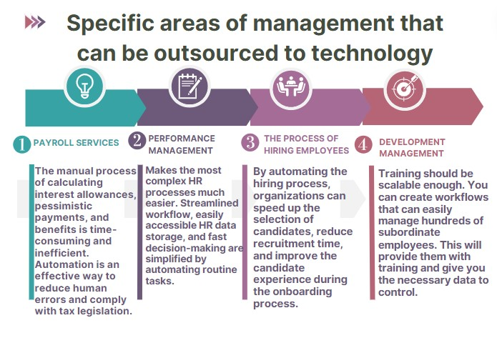

**Figure 1:** Demonstrated specific areas of management that can be outsourced to technology.

Human resources management is an important part of every organization. Whether it's hiring new employees, training, or ensuring compliance with local labor laws, HR processes are an important part of every organization. HR automation is a process that improves efficiency in the workplace by freeing employees from tedious manual work and allowing them to focus on more complex tasks, such as decision-making and strategy development. By automating standard and repetitive HR tasks, organizations can reduce costs and time spent on manual HR planning and data processing. Through strategic automation, HR teams can reduce paperwork and focus on more strategic roles of the HR department. Therefore, in the context of the country's digitalization, effective HR management of public authorities requires automating management processes in public authorities and improving operational processes on HR issues, as well as timely and effective monitoring of the performance of public authorities on HR issues. With this in mind, in the coming years, I aim to study the current state of the implementation of new innovations in government institutions, explore electronic modern platforms for the convenience of employees, determine if and how automation can be seen as an option, and imagine a novel way of doing work marked by responsiveness, sustainability, and transparency. To get rid of the most cumbersome processes related to people and monitoring large amounts of information, automation can be divided into four blocks

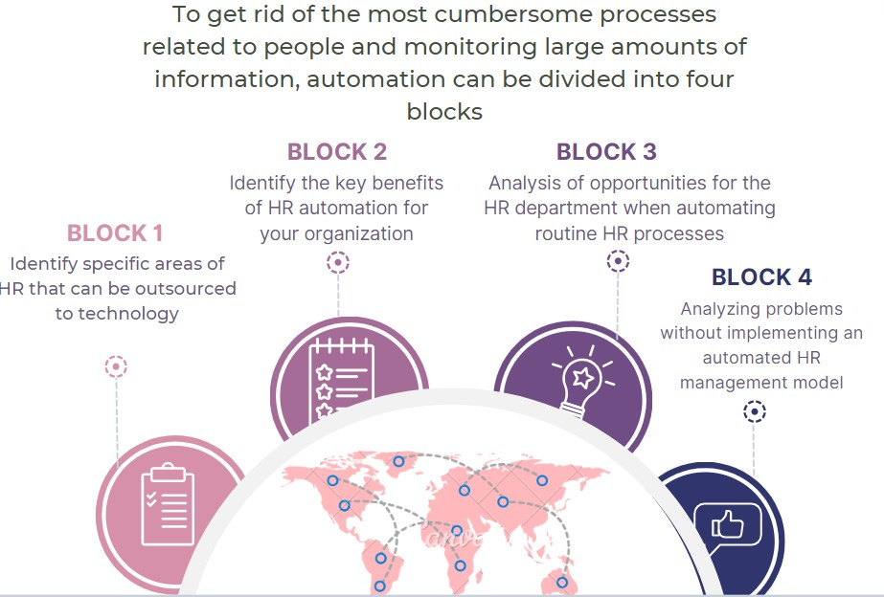

**Figure 2:** There are four blocks that can be used to structure the automation of cumbersome HR processes in an organization.

The transition to digital technologies for government personnel agencies will increase the efficiency of personnel processes and save costs. A paperless civil protection service will be able to process many more documents in the same amount of time than manual processing. In addition, digitization reduces the cost of paper, printers, ink, postage, and frees up office space from files of documents and the time of staff working with manual and routine processing of these documents. Saving employees' time is especially valuable in connection with the execution of large amounts of information.

HR processes are one of the core strategies needed to support the employee lifecycle and deliver a positive work experience. Each process follows a complex path that requires strategic planning according to certain parameters and goals. Each process has its own procedure, but all processes are interconnected. To develop an effective performance management process, HR must first ensure that each department's management and organizational strategy is aligned with the organizational strategy, that there is a robust and transparent performance management system in place, and that there is an appropriate structure to complete each step of the process. The HR department can then begin the performance management process, i.e., create a plan, communicate with professionals, and see the results. HR processes act as the organization's cardiovascular system, giving vitality to each department and maintaining the health of the company as a whole. Integrated HR process management means that the HR department is responsible for the execution of each process from start to finish. The process management is comprehensive, including breaking down each task into small steps to ensure that the process runs smoothly. A systematic approach can help HR managers implement effective processes, thereby increasing productivity, retention and engagement in the workplace.

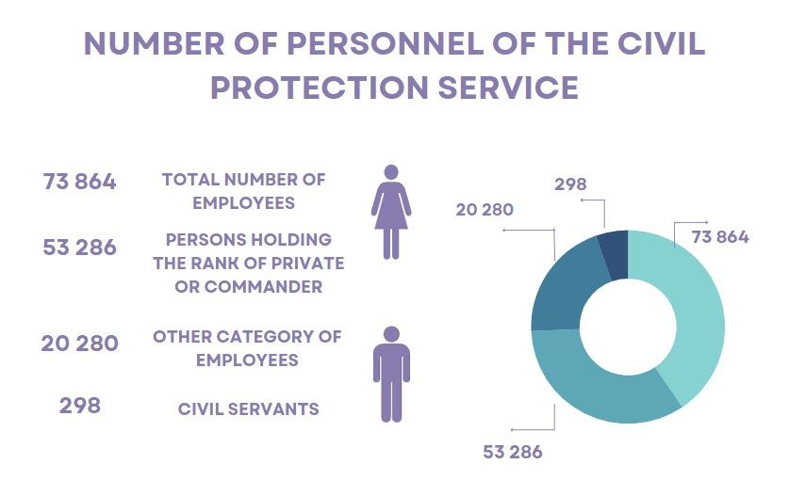

**Figure 3:** demonstrated and analyzed the number of personnel in the civil protection service.

The purpose of this study is to examine the current state of innovation processes in public institutions, to study modern electronic platforms for the convenience of employees, to understand whether digitalization can be considered an opportunity and how it can also represent a new way of working characterized by adaptability, resilience and openness to change. In the context of digitalization of the country, effective HRM in public institutions requires automation of management processes in public institutions, improvement of operational processes on HR issues, as well as timely and effective monitoring of the effectiveness of public institutions on HR issues. Modern society is developing under the influence of a new environment in which digital technologies are becoming increasingly important. Digital technologies can not only significantly increase the productivity and well-being of employees, but also solve management problems. One of the main drivers of technological change in human resources management in public institutions is digitalization, which is the creation and use of derivative technology methodologies and digital algorithms. Successful implementation of new digital technologies in an organization requires technical, organizational and human factors, but it is equally important to meet certain conditions, such as a clear definition of objectives and accurate identification of key players in the organization.

The productive use of advanced and digitized HR processes will inevitably lead to improvements in almost every part of business operations. Even the improvement and automation of just one imperfect HR process can bring significant changes to the operations of public authorities.

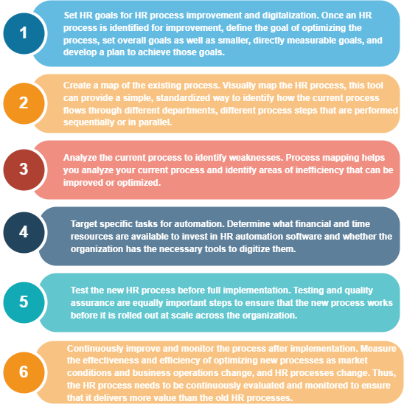

**Figure 4:** Shows the ways to increase productivity when digitizing HR processes.

Concentrate on the stages and steps to improve your organization, align current processes with a realistic and reasonable HR process development strategy with achievable goals, and periodically analyze and communicate progress to stakeholders, management, and staff. Taking these basic steps to improve and optimize HR processes will lead to a more efficient, agile and intelligent organization. Out of hundreds of processes in a company, just one dysfunctional HR process creates a bottleneck and undermines the company's agility.

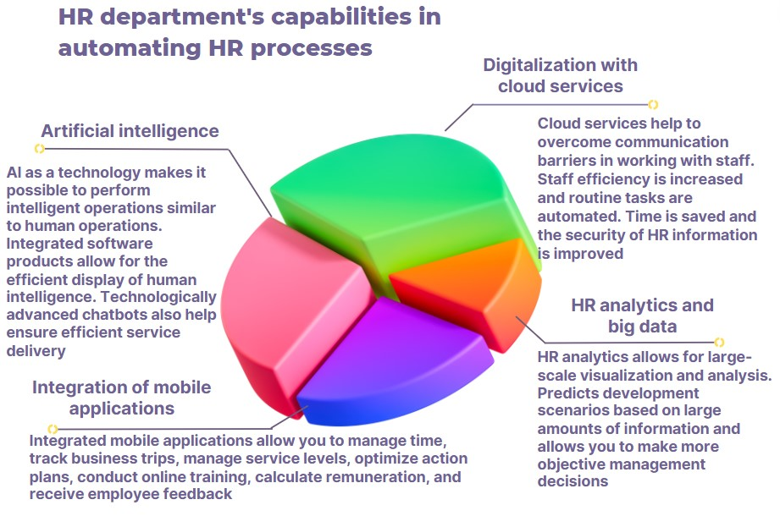

**Figure 5:** shows HR department's capabilities in automating HR processes.

The work of an HR specialist is very important for public institutions. The HR manager acts as a buffer between employees and management, developing brands for public institutions, improving corporate culture, motivating and adapting staff. In addition, they need to keep records, track all sick leave, vacations, business trips, calculate payroll, conduct interviews, plan events, etc. All these tasks must be performed at a high level, as the work of other professionals in government agencies often depends on HR specialists. With the help of automation, you can optimize the number of routine tasks and switch your attention to higher-level tasks, such as team loyalty, motivation, productivity, onboarding, and corporate culture development. How to start automating HR management in your company.

1. You want to be more efficient in your recruitment efforts.

2. You want to have unburdened HR specialists who will be attentive to their staff.

3. You want transparent management of HR processes with the ability to view reports in real time.

4. You want to control the effectiveness of the team.

5. You want to develop employees and promote leaders.

Again, before embarking on a major transformation in the area of HR, first define a clear goal that makes sense from a business perspective. In most cases, this goal is to solve problems that employees are facing. This applies to all stakeholders, from employees to senior management and everyone in between. Transforming digital workforce management to impact the entire organization requires all the support it can get to succeed. Think about which areas of the HR department can be digitalized (pre-employment screening, onboarding, training and development, payroll, etc.). Ask them what they think should be a priority. This will, of course, lead to a long list of suggestions. Organize these ideas according to their importance and impact. First, consider the impact of digitalizing the idea on the business, and second, the time and money required to actually digitalize the idea. In the HR sector, flexibility and integration of processes have become crucial for rapid adaptation to new working conditions. This is stipulated to the rapid adaptation to new working conditions. Digitalization implies a focus on the individual employee, rather than on the standard approach to HR іt is important to understand that digitalization requires an employee-centered approach rather than a standard HR approach. It requires an approach focused on the individuality of the staff. Therefore, it is appreciatively to build processes that focus on the needs, feelings, emotions and behavior of employees. It is appreciatively to build processes that focus on the needs, emotions, feelings and behaviors of employees. For HR departments, this means changing the nature of their HR activities. Development and optimization of functional responsibilities. It is optimization to ensure the most effective interaction of staff for the business. Today it is appreciatively to understand how employees work. It's important to understand how employees work, where they fit in, and what needs to be done to increase their individual and collective effectiveness.

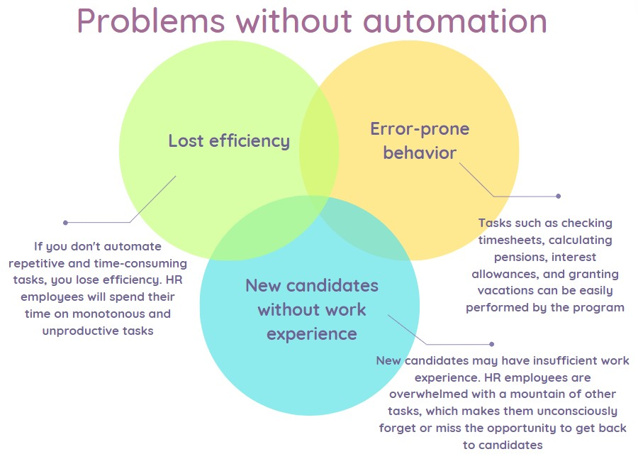

**Figure 5:** shows problems without automation.

Any company adopts solutions to automate HR business processes. There are many reasons for this. But one of the most important is to optimize and accelerate all internal processes. We live in the age of technology, so its use means competitiveness and success. Today it is impossible to automate all processes. Some tasks must be handled by employees. Among them are employee recruitment, management, corporate culture, and communication with customers. This requires the participation of not only machines, but also people with a high level of socialization. In principle, the following process is automated:

1. Managers are part of the strategic management of employees and the company;

2. Operations - all processes that affect the company's work (marketing, technical support, development, etc.)

3. Support of business processes related to system management, logistics, accounting, etc.

4. Tasks with a high level of human involvement.

The automation system helps to transform monotonous manual work into automatic work, making it more technological and advanced. The management process includes ERP and CRM systems for analysis and management. Directors have unlimited access to the Company's data, the right to assign and reassign tasks and conduct in-depth analysis. Tasks with a high level of human factor are special programs for finding and managing employees, chats, portals, etc. Their main task is to facilitate work and simplify communication between employees.

# 4. Conclusions

In today's rapidly changing world, team roles need to be clearly defined from the outset so that management and staff can quickly adapt to the digital mindset. Traditional HR systems need to be improved and redesigned as they are refined, modernized and adapted to the digital mindset. It may be necessary to create an automated information organizational structure for government agencies, but they also need to think about a long-term strategy. This concept must also be adapted to the latest technological realities of today. Innovation is a critical HR management strategy and an important HR strategy in general. In combination with in-depth knowledge of all HR processes and functions, it is essential to build a team that can monitor, analyze and implement new technologies that are emerging almost every day. It is important to build a team that can monitor, analyze and implement new technologies that are emerging almost every day. Another important topic is the attitude towards employees in the wake of digitalization. You need to treat your employees as customers and build relationships with them. The digital transformation of public services in Ukraine is gaining momentum. The introduction of accessible and simple e-services, digitalization in a fundamentally new system of organizing production and service delivery in various areas, including administration, helps to reduce the impact of human factors and corruption in the provision of public services, increase quality and efficiency to improve life, work, research and recreation. This is a good idea. All public services should be transparent, understandable and automated with the help of smartphones and computers for faster response and access to information about the staff.

Your employees are your customers, so you need to increase the level of engagement with your employees, and help them grow and advance their careers. By strengthening your relationships with your employees, you can contribute to their career advancement and overall growth.

It is essential to monitor events in the rest of the sector, as important as the evolution of public institutions in economically developed countries. The impact of digitalization and automation on human resources is growing. By digitizing HR processes and services, organizations can improve employee performance, increase efficiency and reduce costs. This is because digitization allows HR to automate repetitive tasks such as data entry, payroll processing, query tracking, and documentation, freeing up time for more useful activities such as recruiting, talent management, training, and development. HR data is increasingly being digitized, which means it can be used more efficiently than ever before. Human resources departments can use more data to make better decisions on HR issues, such as hiring and training, which will increase employee satisfaction and productivity in the organization. Digitalization and automation can bring significant benefits to government agencies, allowing HR departments to free up time from manual, repetitive tasks and focus on more strategic activities.

What technologies do they use, how do they increase efficiency, and how do they create a good working environment for employees, because employees are the company's biggest asset and the company's future depends on them. The employees are the company's greatest asset and the company's future depends on them because they are the company's greatest asset and the company's future depends on them.

# 5. References

1. A. Lysenko Models and methods of project team formation using the theory of precedents: PhD thesis: 05.13.22. Kharkiv, 2009. 15 р.
2. A. Lysenko Optimization models of production planning taking into account uncertainty. Control, navigation and communication systems. Collection of scientific papers. Odesa, 2017. 2 (42). Р. 167-170.
3. Digitalization of business: how to grow in times of war. URL: <https://business.diia.gov.ua/cases/iniciativi/cifrovizacia-biznesu-ak-zrostati-v-umovah-vijni-vebinarnij-proekt-zakinceno-dostupni-zapisi-efiriv>.
4. E. Dolan, S. Kosasi, S. Nurinda Sari. Implementing competency-based human resource management in the digital era Startupreneur Business Digital (SABDA Journal), No. 2, 2022.
5. Guide to the Project Management Body of Knowledge (PMBOK® Guide). Sixth Edition. Project Management Institute. 2017. 496 р.
6. I. Sedikova, K. Kozak, D. Sedikov Personnel management in the conditions of global information processes. Economics of the food industry. 2020. Vol. 14, No. 2. Р. 27-33.
7. І. Zasukha, S. Bushuyev, N. Bushuyeva Concentric model of the digital footprint of projects. International scientific journal "Grail of Science" № 8. 2021. Р. 193-201.
8. І. Zasukha Digitalization project management in the public sector: PhD thesis ... Candidate of Technical Sciences: 05.13.22. Project and program management. 2021. 40 р.
9. I. Sencha, K. Peklun A competent approach to the management of human resources of projects: The effectiveness of modern methods and tools. Actual problems of public administration. 2019. № 4(80). Р. 127–131.
10. L. Sabadosh Methods of managing the provision of human resources for projects and programs by competence approach: PhD thesis: 05.13.22. Kharkiv, 2014. 21 р.
11. L. Chorna, O. Zachosa Mechanism of management of human capital development in the conditions of activation of the knowledge economy. Economy and state. 2017. № 3. Р. 36-38.
12. L. Shevchenko Development of business models in the digital economy. Digital Transformations of Ukraine 2020: Challenges and Realities: Collection of scientific papers of the Research Institute of IPR of the National Academy of Pedagogical Sciences of Ukraine № 1 based on the materials of the round table, September 18, 2020. Р. 183-188.
13. L. Yaremko New Economy and Innovative Development. Marketing and management of innovations. 2011. №3. VOL. 1. P. 25-30.
14. M. Gladka Models and methods of multiagent allocation of labor resources in IT projects under conditions of uncertainty: Candidate of Technical Sciences (PhD): 05.13.22. Kyiv, 2021. 140 р.
15. M. Vedernikov, N. Bazaliyska. Innovative technologies of personnel management of an industrial enterprise. State and regions. Series: Economics and entrepreneurship. 2018. № 3. С. 72-78.
16. N. Bushuyeva, Y. Yaroshenko, R. Yaroshenko Project management and organizational development programs: a textbook. K: Summit Book, 2010. 200 с..
17. O. Brintseva, O.Bilovus Information technologies in the management of enterprise personnel: current trends. Social and labor relations: theory and practice. 2018. № 1. С. 264-271.
18. O. [Kovalchuk,](https://www.scopus.com/authid/detail.uri?authorId=57221860471) O. [Zachko,](https://www.scopus.com/authid/detail.uri?authorId=57194169062) D. [Kobylkin,](https://www.scopus.com/authid/detail.uri?authorId=57205439227) T. [Hiroshi.](https://www.scopus.com/authid/detail.uri?authorId=56939506200) IT development of HR-systems in the field of human safety. [CEUR Workshop Proceedings](https://www.scopus.com/authid/detail.uri?authorId=57194169062#disabled). 2021, 2851, Р. 314–323.
19. О. Butnyk Online state: Estonia's experience in the dissemination of electronic services. Building an Information Society: materials of the International Scientific and Practical Conference, Kyiv, September 19-20, 2019. Kyiv, 2019. С. 197-201. DOI : [www.shrm.org/foundation](http://www.shrm.org/foundation).
20. S. Bushuyev, D. Babayev, B. Bushuiev. Emotional Infection of Management Innovation SMART Government Projects 2020 IEEE European Technology and Engineering Management Summit, E-TEMS 2020, № 9111796 .
21. S. Tsymbalyuk Technologies of personnel management: a textbook. K.: KNEU, 2009. 399 р.
22. S. Shcheglyuk Morphology of the digital economy: features of development and regulation of digital technology platforms [Electronic resource]. DOI: <http://ird.gov.ua/irdp/e20190301.pdf>.
23. V. Piterska, V. Samoilovska, V. Shakhov і H. Tanaka Risk-oriented port management in the process of implementing concession projects. The current state of scientific research and technology in industry, 2(24), Р. 200–211. DOI:  <https://doi.org/10.30837/ITSSI.2023.24.200>
24. V. Vasyliv Information systems for managing the human resources of the university. Bulletin of the National University of Water and Environmental Engineering. 2014. Issue 1. pp. 47-56.
25. V. Vasyliv Information systems of personnel management: a textbook. Rivne: NUWHP, 2014. 148 с.
26. What is a digital wallet and how does it legalize e-documents throughout the European Union. BIT.UA. URL: https://bit.ua/blog_columns/european-digital-identity-wallet/

1.