UDK 614.847.15
Popovych V.V., Kovalchuk V.M.
(Lviv State University of Vital Activity Safety, Ukraine)

FEATURES OF PEOPLE EVACUATION DURING FIRES BY MEANS OF FIRE LADDERS AND VEHICLE LIFTS

In the following article the authors highlighted the problem of conditions and possibility of evacuation of people during fires from multi-storey buildings using fire ladders and vehicle lifts. There was also proved the necessity of providing Operational Rescue Service Units of Civil Protection of Ukraine with fire appliances depending on the features of the actions area.

Fire statistics of multi-storey buildings shows that the increased pace of high-rise building is directly connected with the growing number of fires. Development of fire in high buildings, i.e. flame speed and temperature growth, is more stringent than in other buildings that causes increased complexity of fire extinguishing, providing evacuation of people and rescue actions. In connection with the mentioned above, the problem of safe evacuation of people from high-rise residential and multifunctional buildings is especially important. The criteria of safe evacuation are timeliness and lack of obstacles [1].
Law regulations reflect many aspects of this problem, however, public specificity of acceptance of rules as dogma, and the probability of inclusion the incorrectly formulated statements do not always allow to ensure safe evacuation while designing high-rise buildings. During evacuation organization one should take into account the influence of numerous factors: accumulation of large number of people of all ages and physical condition, geometrical dimensions of passageways and stairwells (ways of evacuation), possible use of fire ladders or vehicle lifts. The successful rescue of people should imply designed control evacuation system that includes warning blocks, fire and protection alarms, evacuation management, control and management of building access and emergency lighting. In this system the evacuation options depending on the fire location and character should be foreseen. Each option is to be considered with the aim of verifying the compliance with modern terms, unimpeded access for firefighters and evacuation process [2].
One of the most reliable ways of people evacuation from buildings that are covered with fire- is by means of aerial fire ladders and vehicle lifts.
According to [3] the fire ladder – is a fire appliance equipped with a stationary mechanized pivoting retractable ladder; while a vehicle lift – is a fire vehicle equipped with a stationary mechanized pivoting lifting boom, which ends with a platform or a pipe. The main functional purpose of both types of appliances is rescue of people from high-rise buildings (evacuation). The experience of fire ladders and vehicle lifts operating shows that in terms of optimal combination of strength and resilience requirements with limitations of dimensions and weight, as well as unit costs, the working height of 52-55 meters is the limit for them [2].
According to the State Department of Logistics of the Ukrainian Ministry of Emergencies data, the units of the Operational and Rescue Service of Civil Protection of Ukraine have 307 fire ladders and 50 fire vehicle lifts, the need for this type of vehicle is significant, namely - 140 fire ladders and 28 fire vehicle lifts. In particular, 7 fire vehicle lifts are needed for Headquarters of Ukrainian Ministry of Emergencies in Lugansk region; in Dnipropetrovsk, Zhytomyr, Zaporizhzhya and Khmelnytsk regions (3 in each). Number of fire ladders, which is essential for Headquarters of the Ukrainian Ministry of Emergencies in the regions is: 20 in Dnepropetrovsk, 18 in Donetsk, 14 in Lugansk, 11 in Rivne and 7 in Kyiv.
According to brands, vehicles are classified as follows: 181 fire ladders - АД-30(131)ПМ506, 107 – АД-30(131)Л21, 4 – АД-50(53213), the rest of fire ladders are being operated in small quantities. It should be acknowledged that there are modern fire ladders of 53 meters height with a centrifugal fire pump - Metz DL 53 in 2 fire units (Fig. 1).

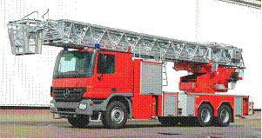

Fig.1. The most modern fire ladder in Ukraine - Metz DL 53

Vehicle lift is considered to be one of the most innovative technical means and is constantly being widely used as the tool for people rescue and evacuation. Its function is similar to the one of the fire ladder, however, vehicle lifts have some advantages: they provide delivery of extinguishing agents and personnel into hardly accessible places, which are at high altitude and which can not be reached by the top of the ladder. Additionally, in case of impossible fire appliance close access to the building, vehicle lift can be set at a further distance.
In Ukraine vehicle lifts , such as АКП-30(53213) – 16 items and Bronto Skylift-30(53213) – 12 items, are mostly used. There is also one vehicle lift, which is 90 meters heigh - Bronto Skylift F90HLA based on Mercedes-benz Actros 4150 (Fig. 2).

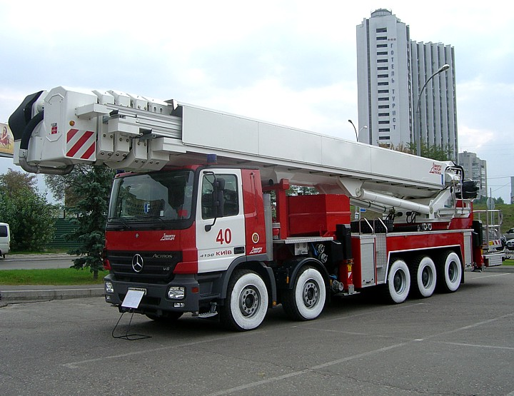

Fig.2. The most modern vehicle lift in Ukraine - Bronto Skylift F90HLA
After analyzing the statistics data it can be concluded that the biggest regions of Ukraine are not fully supplied with special fire equipment that is designed to rescue and evacuate people from multi-storey buildings.

Literature:
1. Холщевников В.В. Нормирование безопасной эвакуации людей из высотных зданий / В.В. Холщевников, Д.А. Самошин. Промышленное и гражданское строительство. - 2007. - №2. - C. 50–52.
2. Григорьева Н.А. Особенности обеспечения безопасной эвакуации и спасения и самоспасения людей при пожарах в высотных зданих / Григорьева Н.А. // Научный информационный сборник «Проблемы безопасности и чрезвычайных ситуаций». - № 3. – М. - 2009. – С. 78-83.
3. ДСТУ 2273-2006 «Протипожежна техніка. Терміни та визначення основних понять».

